Thermocouple
# Source: AI Source: Provided by: [Data Path: Persons Table -> ID Column: 1, Name_En Column: Motasem Essam] -> From: [ChatGPT] on [7/17/2026]
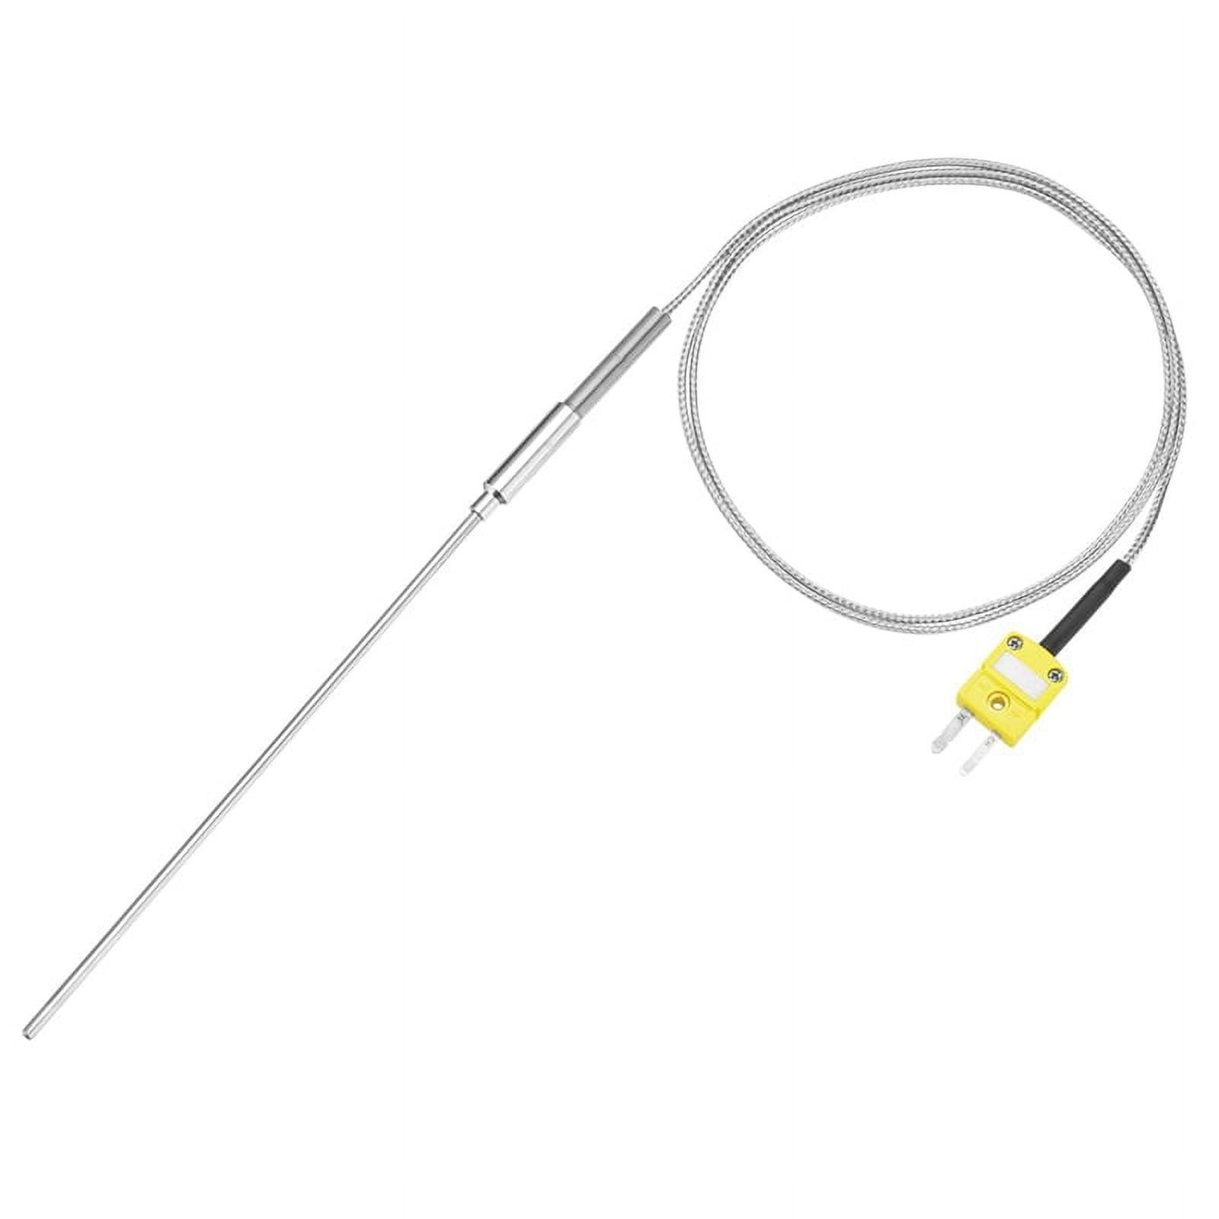
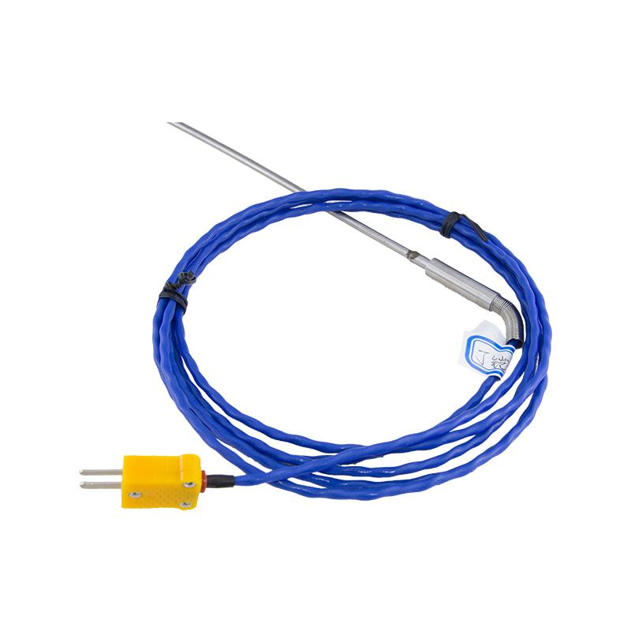
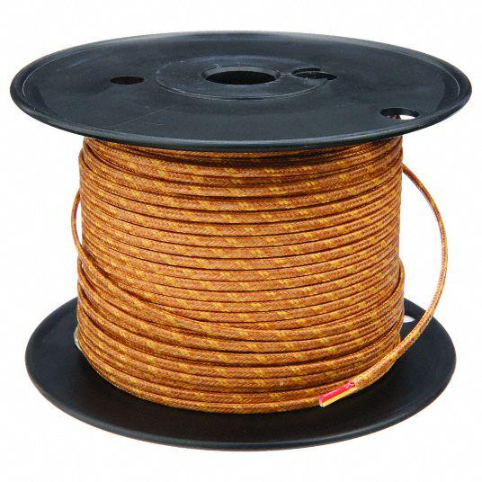
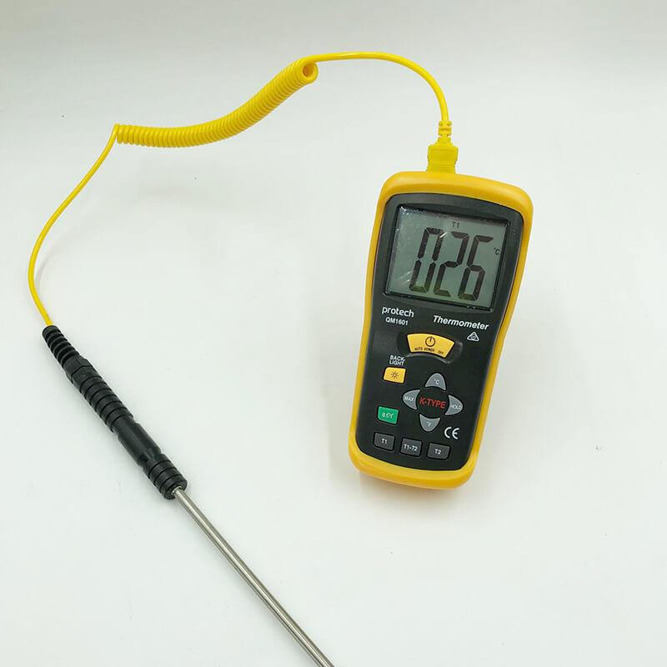
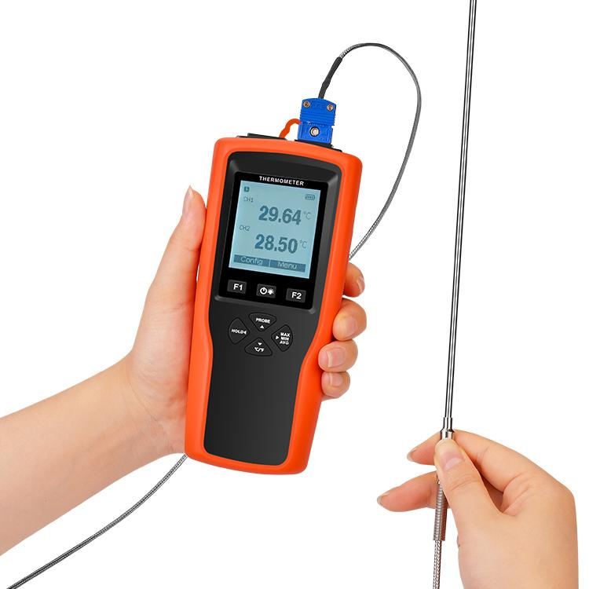
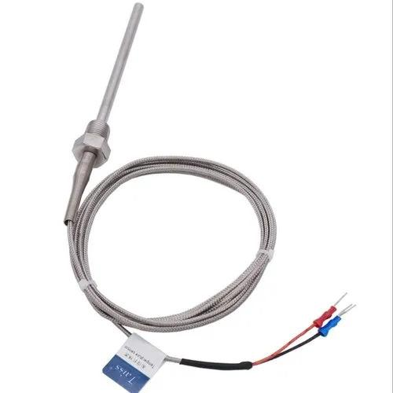
A Thermocouple is a contact temperature-measuring sensor that measures temperature by generating a small electrical voltage when two dissimilar metal wires are joined together and subjected to a temperature difference. This phenomenon is known as the Seebeck Effect.
Thermocouples are among the most widely used temperature sensors because they offer a very wide temperature range, fast response, rugged construction, and relatively low cost. They are commonly used in industry, laboratories, power plants, HVAC systems, food processing, metallurgy, aerospace, and scientific research.

Definition
# Source: AI Source: Provided by: [Data Path: Persons Table -> ID Column: 1, Name_En Column: Motasem Essam] -> From: [ChatGPT] on [7/17/2026]
A Thermocouple is a temperature sensor consisting of two dissimilar metal conductors joined at one end that measures temperature through the voltage generated by the Seebeck Effect.

Purpose
# Source: AI Source: Provided by: [Data Path: Persons Table -> ID Column: 1, Name_En Column: Motasem Essam] -> From: [ChatGPT] on [7/17/2026]
A thermocouple is used to:
- Measure high temperatures.
- Measure low temperatures.
- Monitor industrial processes.
- Control furnaces and ovens.
- Measure laboratory temperatures.
- Monitor engines and turbines.
- Measure HVAC system temperatures.
- Temperature monitoring in manufacturing.

Principle of Operation
# Source: AI Source: Provided by: [Data Path: Persons Table -> ID Column: 1, Name_En Column: Motasem Essam] -> From: [ChatGPT] on [7/17/2026]
A thermocouple operates using the Seebeck Effect.
When two different metals are joined and the junction experiences a different temperature from the reference end, a small voltage is generated.
The thermometer or controller measures this voltage and converts it into temperature.

Main Components
# Source: AI Source: Provided by: [Data Path: Persons Table -> ID Column: 1, Name_En Column: Motasem Essam] -> From: [ChatGPT] on [7/17/2026]
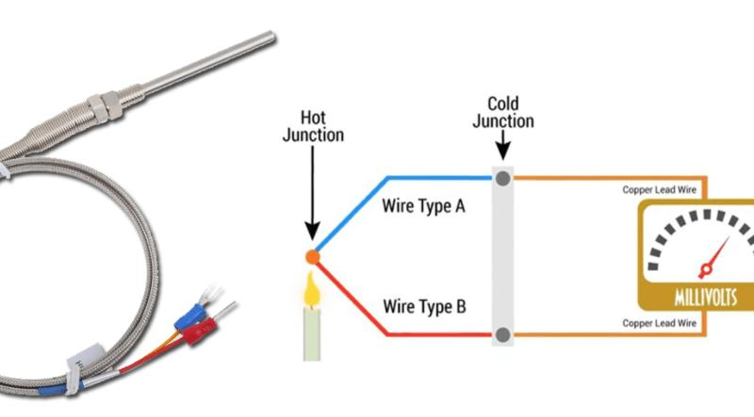
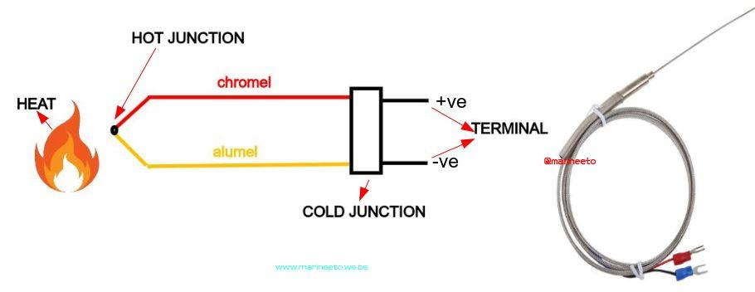
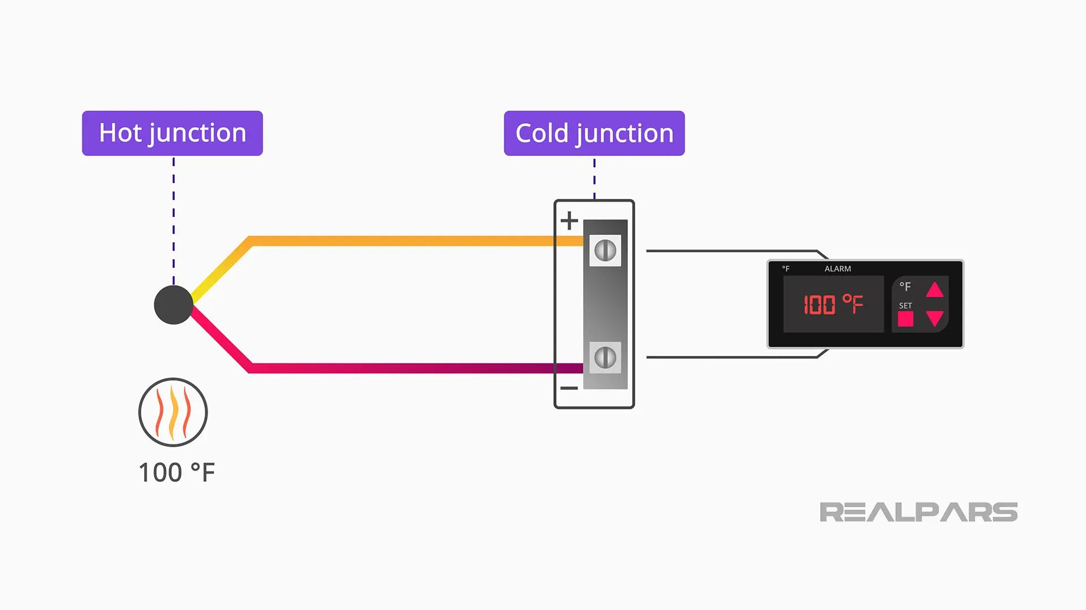
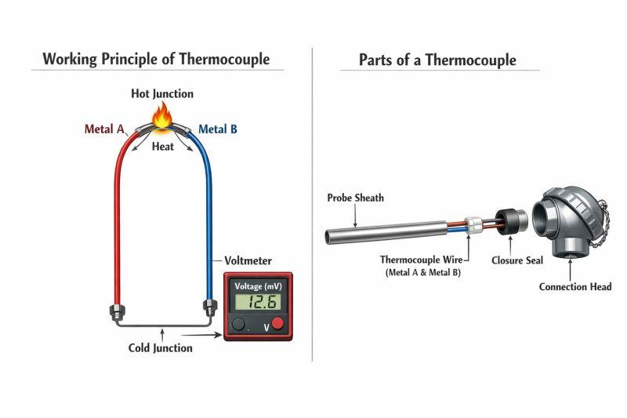
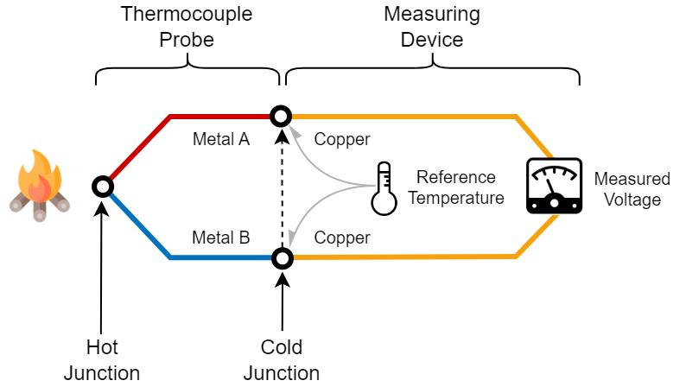
A typical thermocouple consists of:
- Hot junction (measuring junction)
- Two dissimilar metal wires
- Protective sheath (optional)
- Insulation
- Connector
- Measuring instrument or controller

Types of Thermocouples

1. Type K Thermocouple
# Source: AI Source: Provided by: [Data Path: Persons Table -> ID Column: 1, Name_En Column: Motasem Essam] -> From: [ChatGPT] on [7/17/2026]
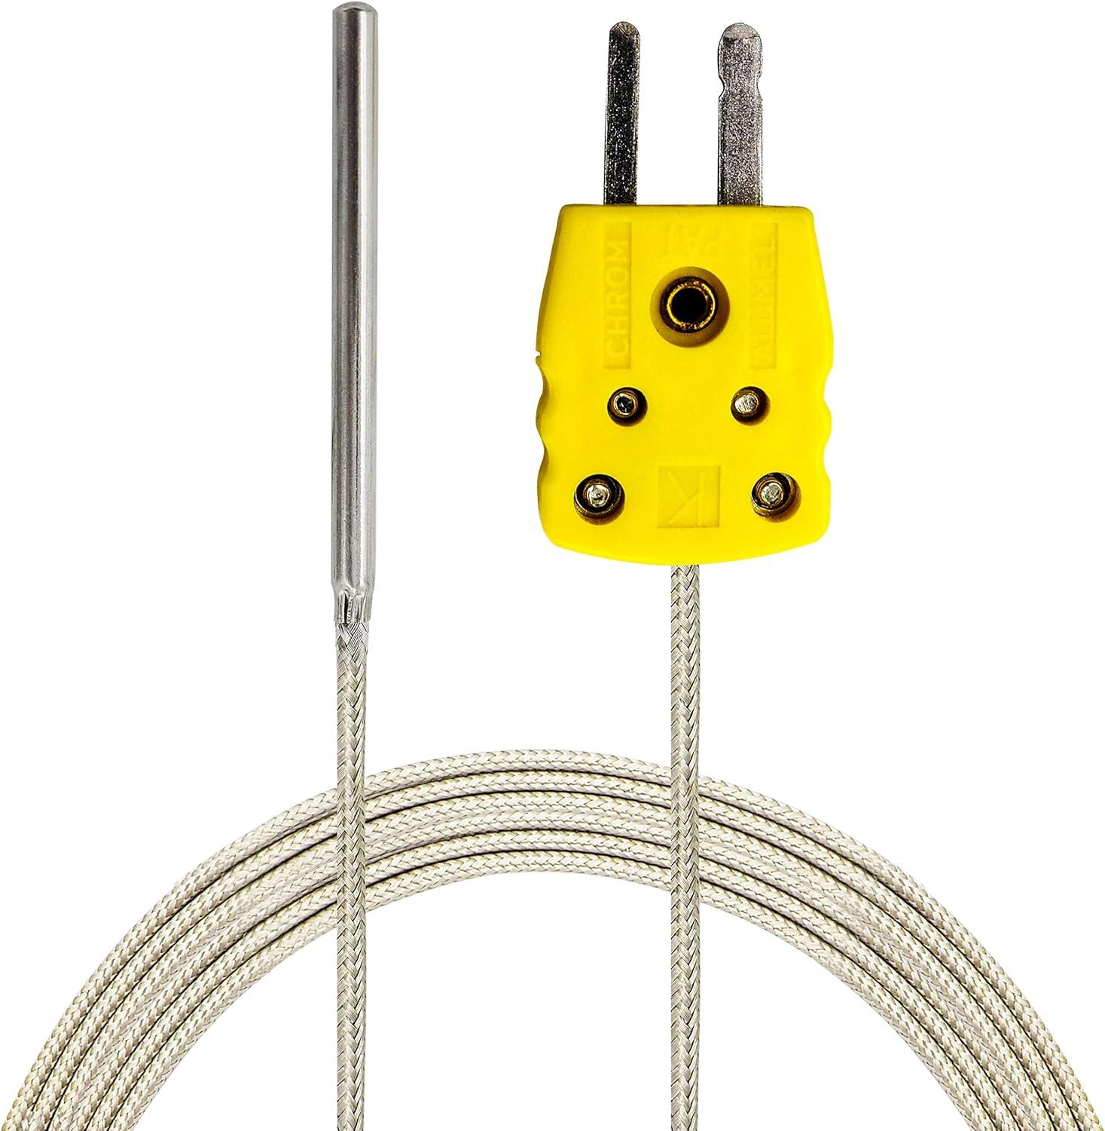
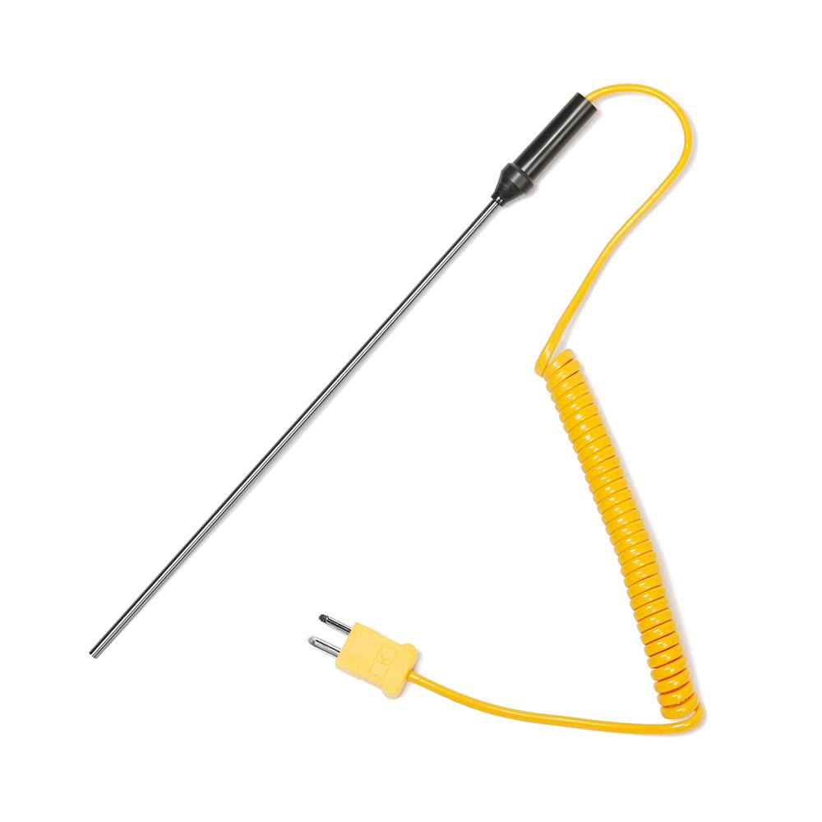
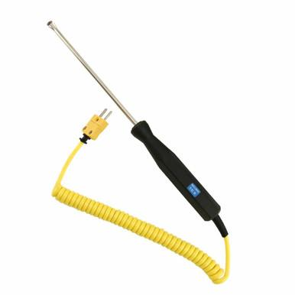
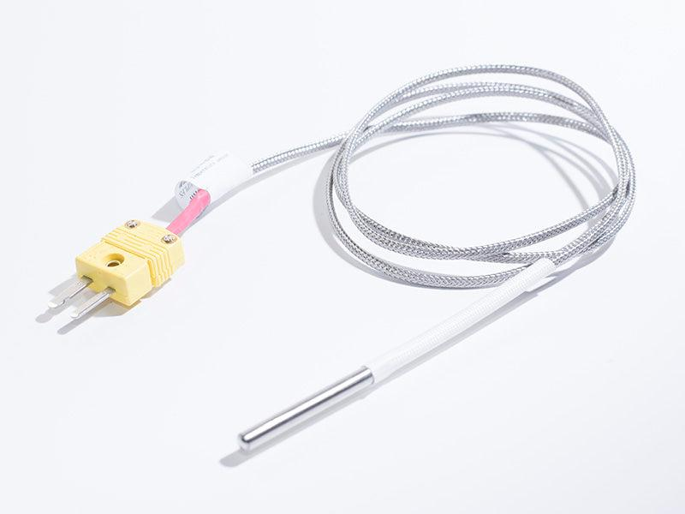
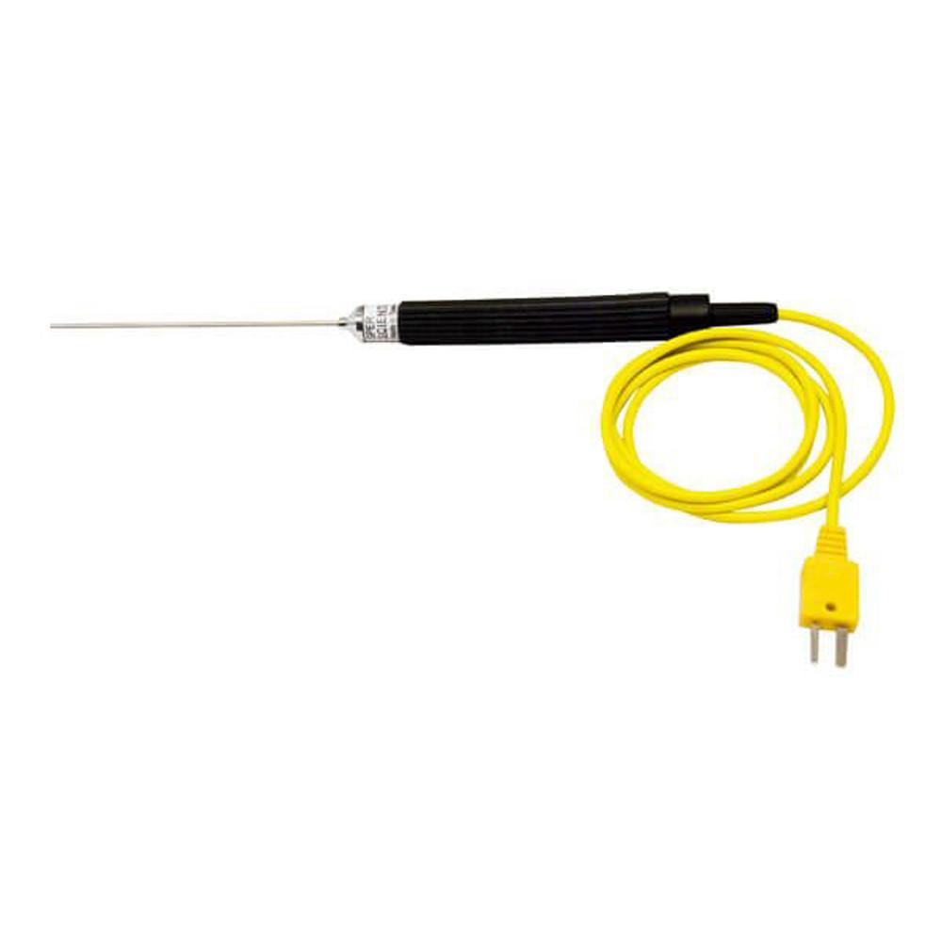
Materials
- Chromel
- Alumel
Measuring Range
Approximately:
−200°C to 1260°C
Features
- Most widely used
- Good oxidation resistance
- General-purpose sensor
Applications
- Industry
- Laboratories
- Furnaces
- HVAC

2. Type J Thermocouple
# Source: AI Source: Provided by: [Data Path: Persons Table -> ID Column: 1, Name_En Column: Motasem Essam] -> From: [ChatGPT] on [7/17/2026]
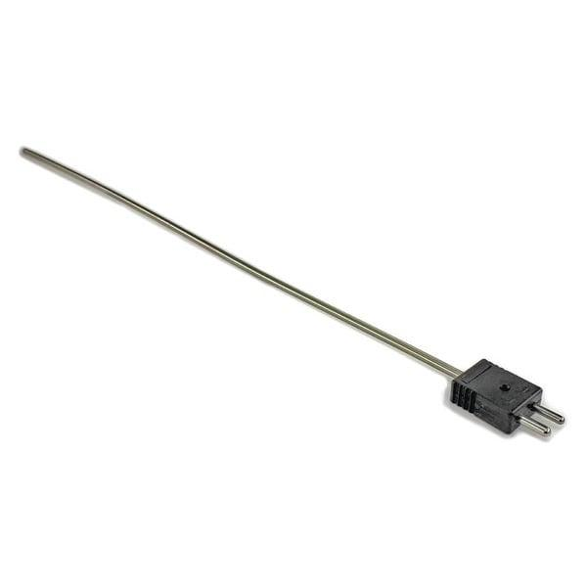
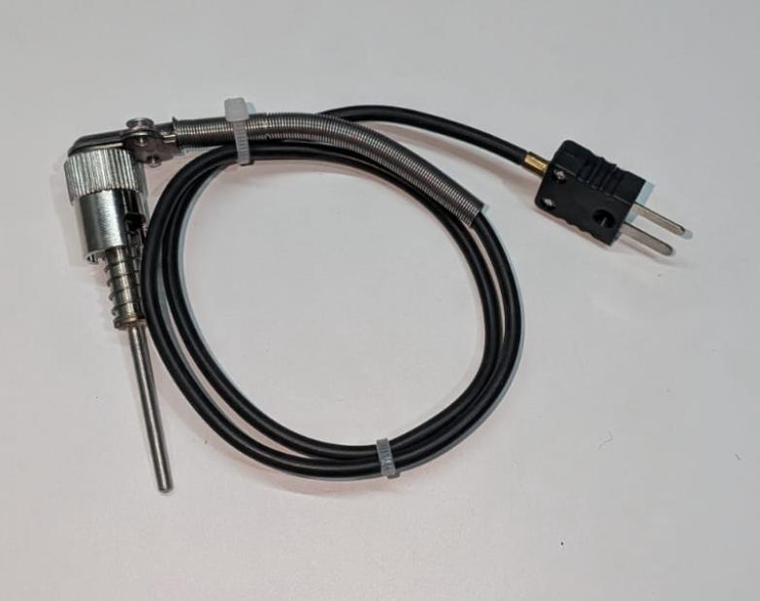
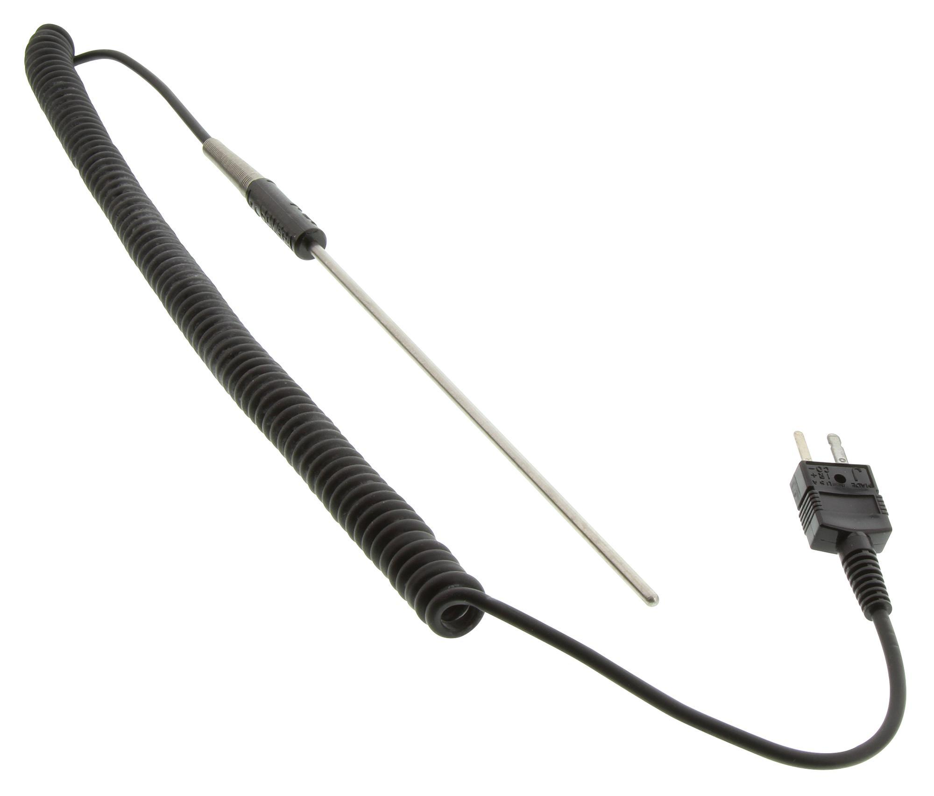
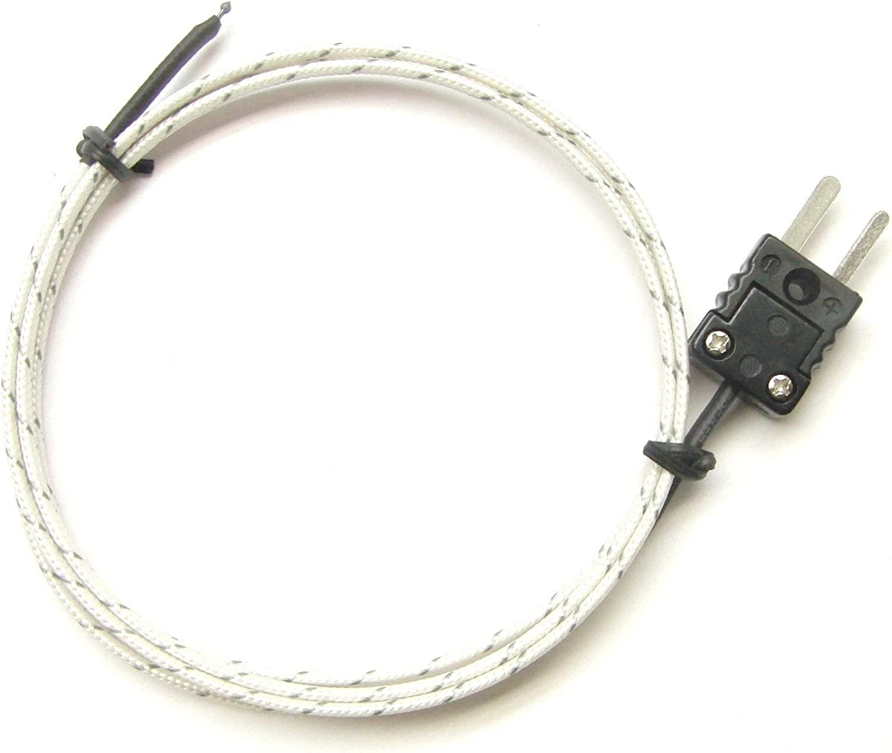
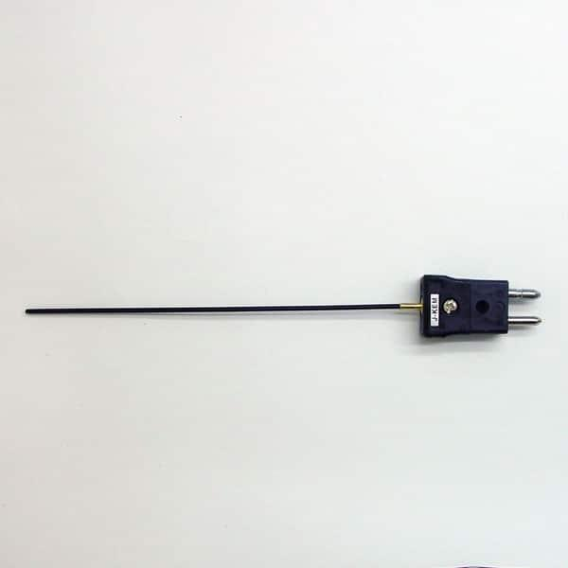
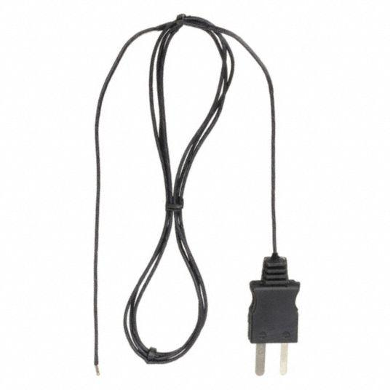
Materials
- Iron
- Constantan
Measuring Range
Approximately:
−40°C to 750°C
Applications
- Industrial equipment
- Plastic processing
- Heat treatment

3. Type T Thermocouple
# Source: AI Source: Provided by: [Data Path: Persons Table -> ID Column: 1, Name_En Column: Motasem Essam] -> From: [ChatGPT] on [7/17/2026]
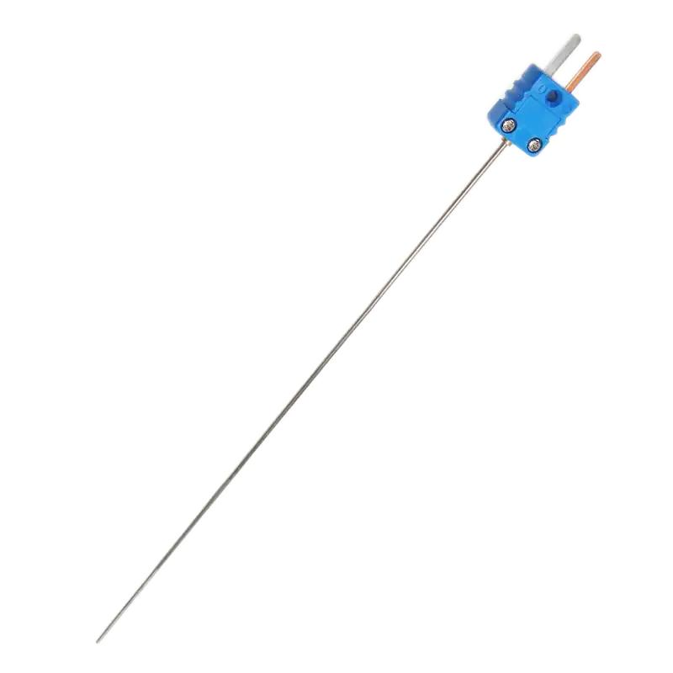
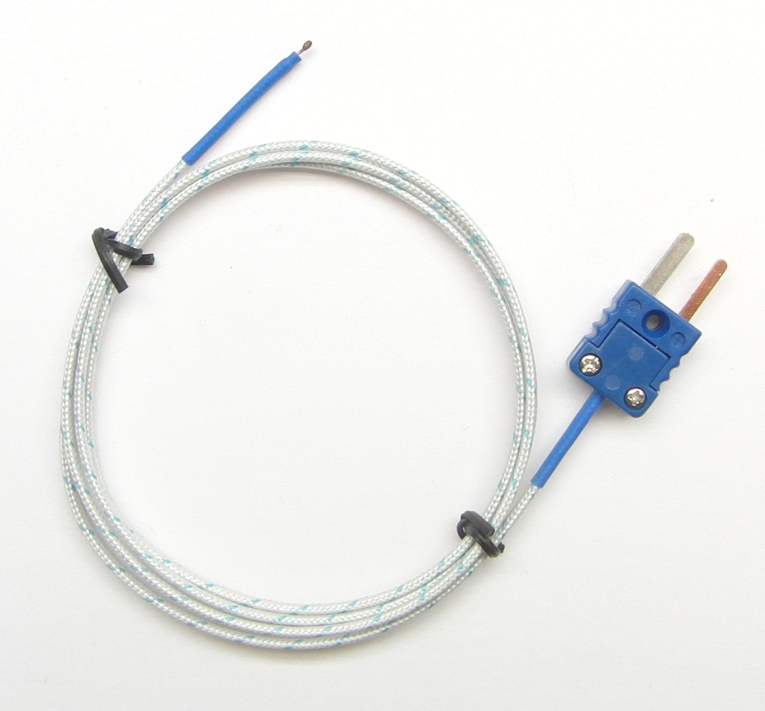
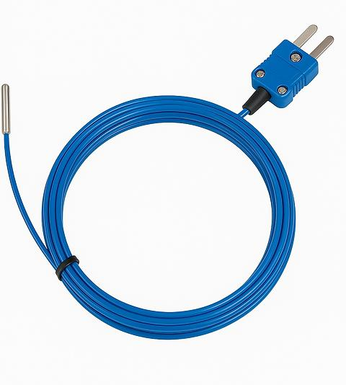
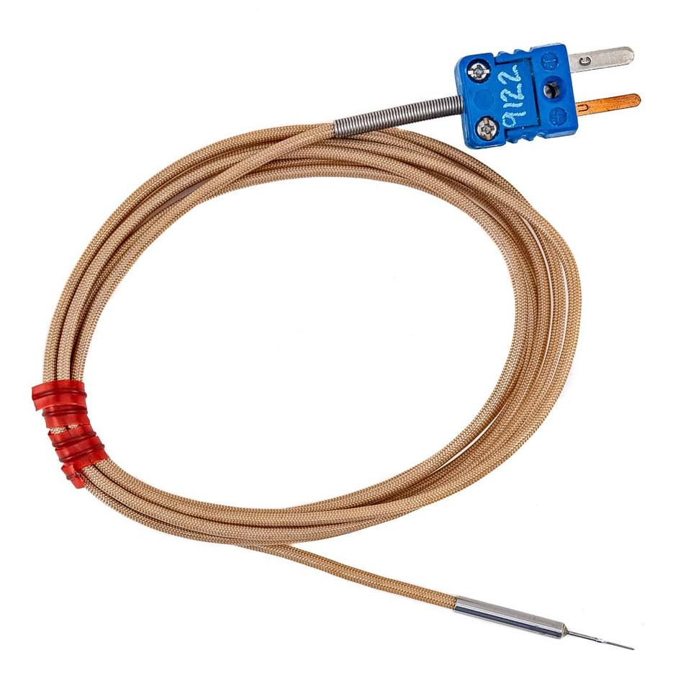
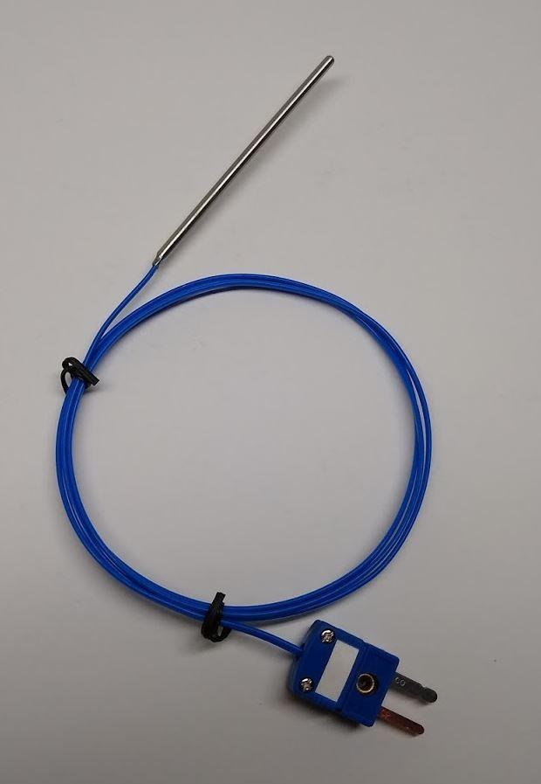
Materials
- Copper
- Constantan
Measuring Range
Approximately:
−200°C to 350°C
Applications
- Cryogenic measurements
- Food industry
- Laboratories

4. Type E Thermocouple
# Source: AI Source: Provided by: [Data Path: Persons Table -> ID Column: 1, Name_En Column: Motasem Essam] -> From: [ChatGPT] on [7/17/2026]
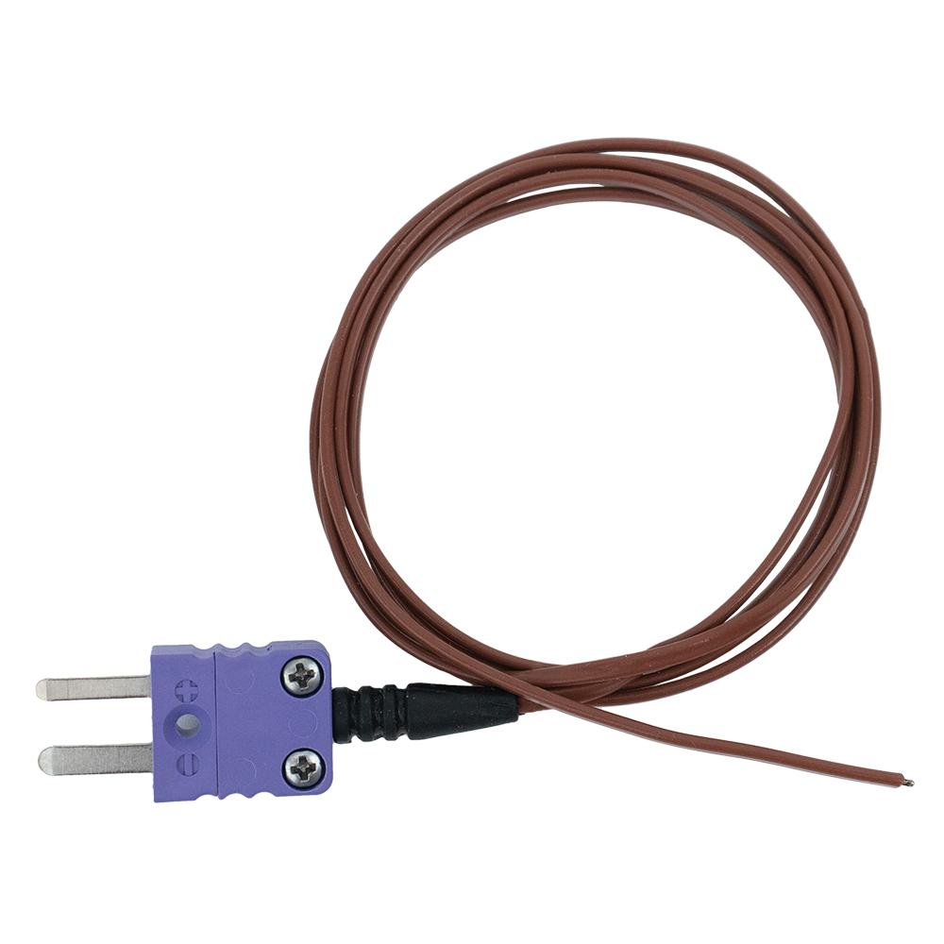
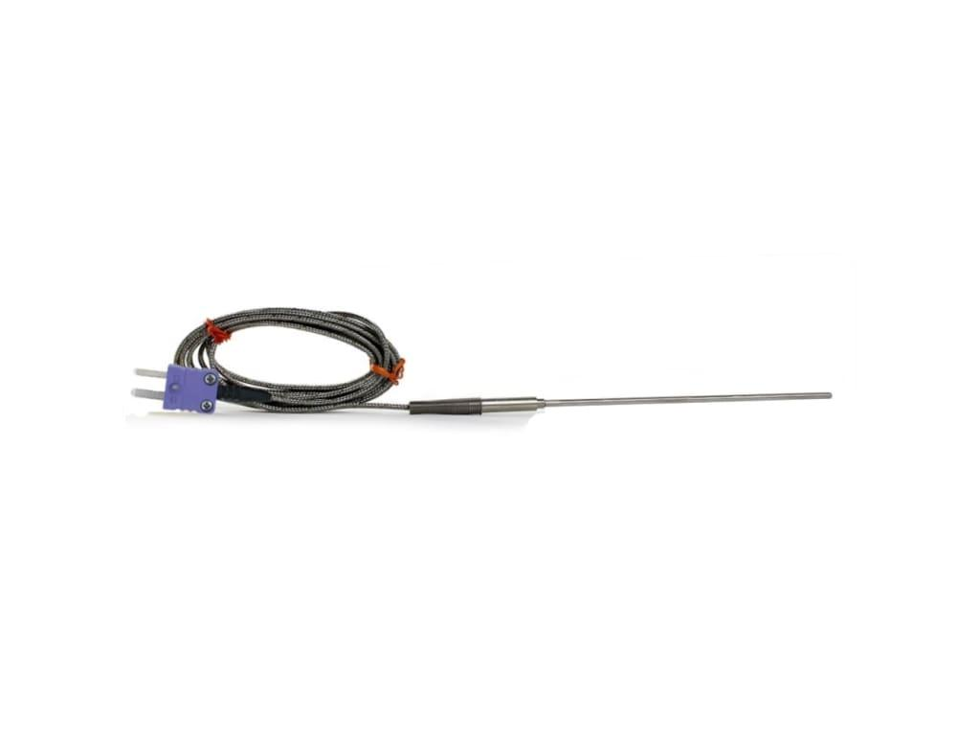
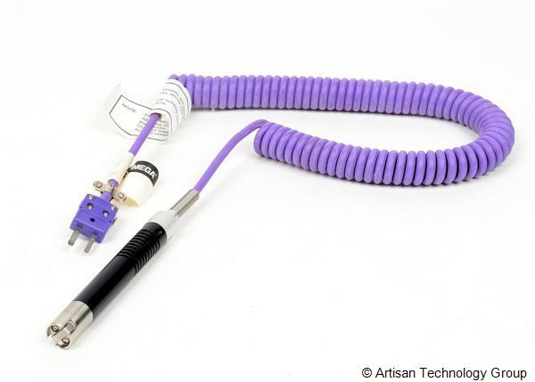
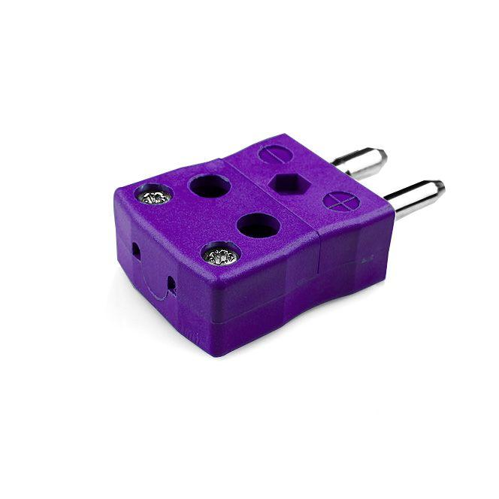
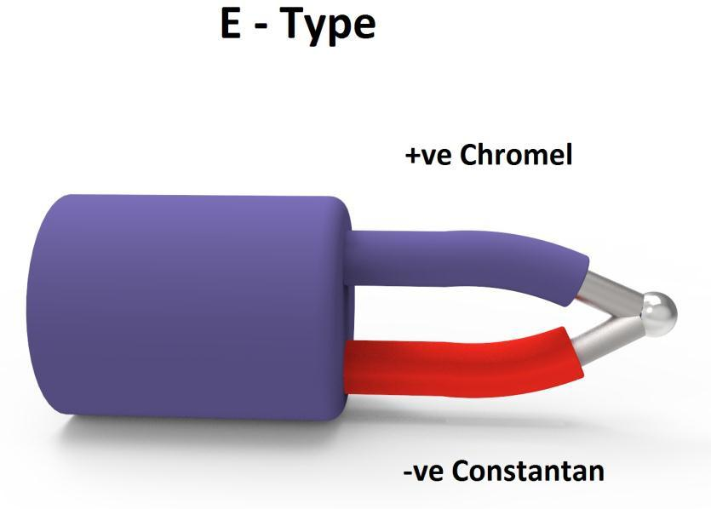
Materials
- Chromel
- Constantan
Measuring Range
Approximately:
−200°C to 900°C
Features
- High output voltage
- Good low-temperature sensitivity

5. Type N Thermocouple (Nicrosil–Nisil)
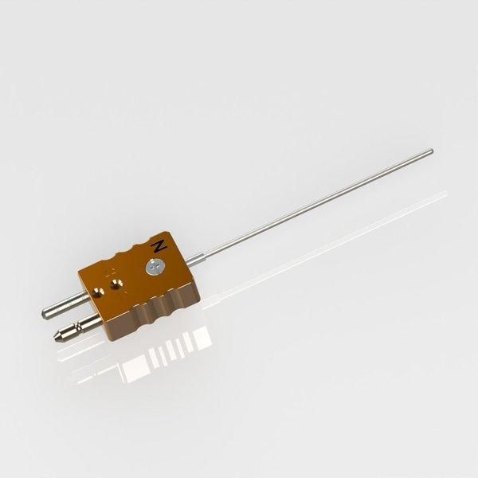
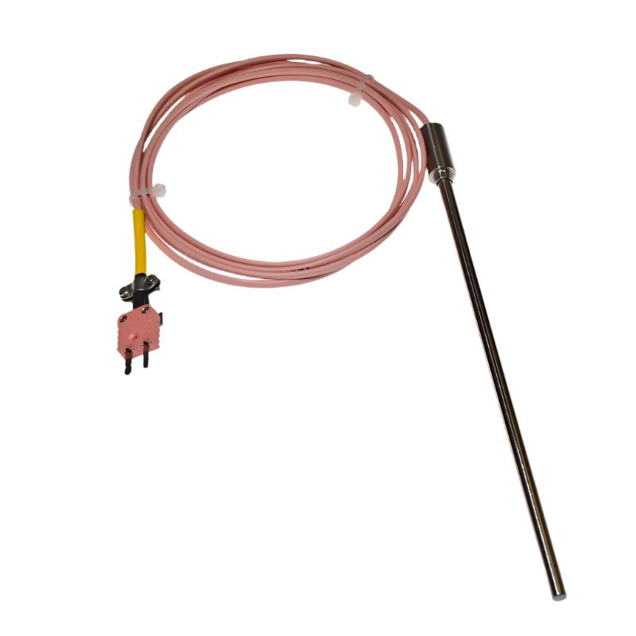
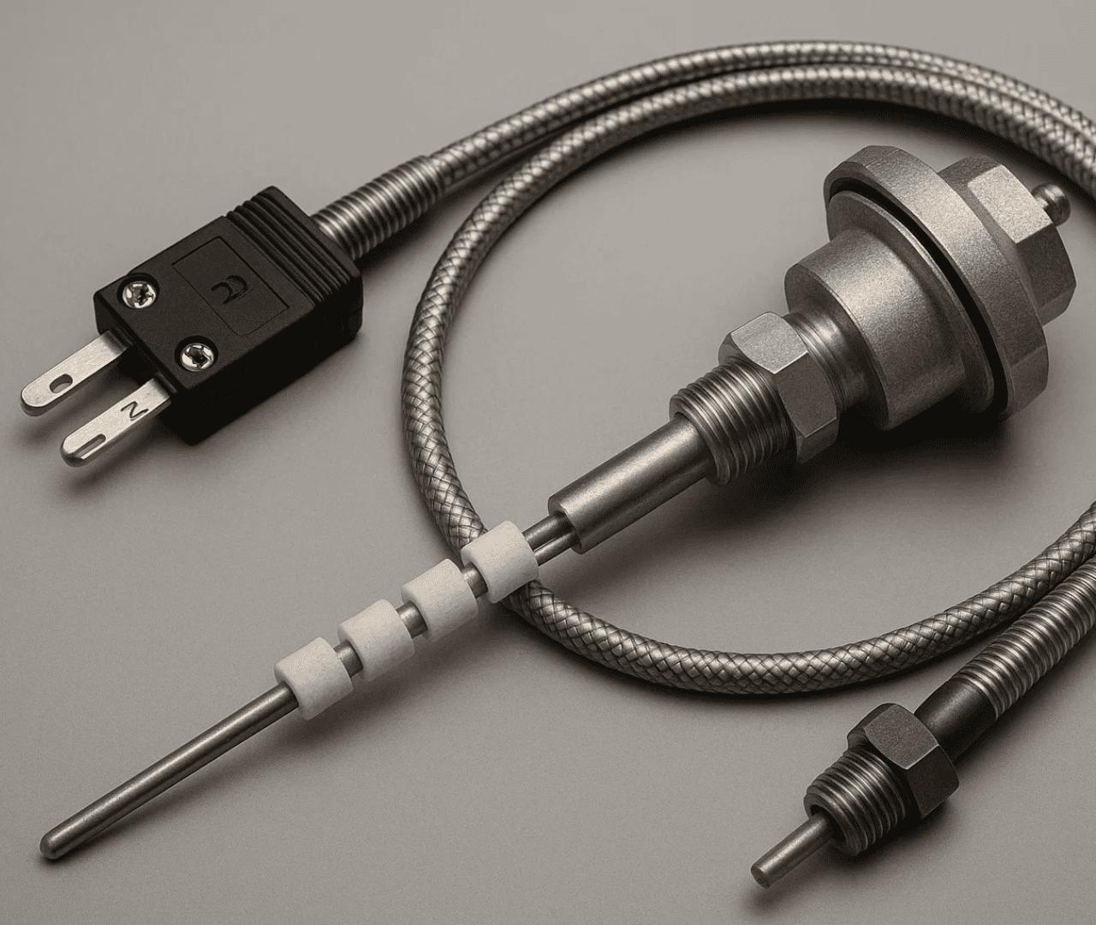
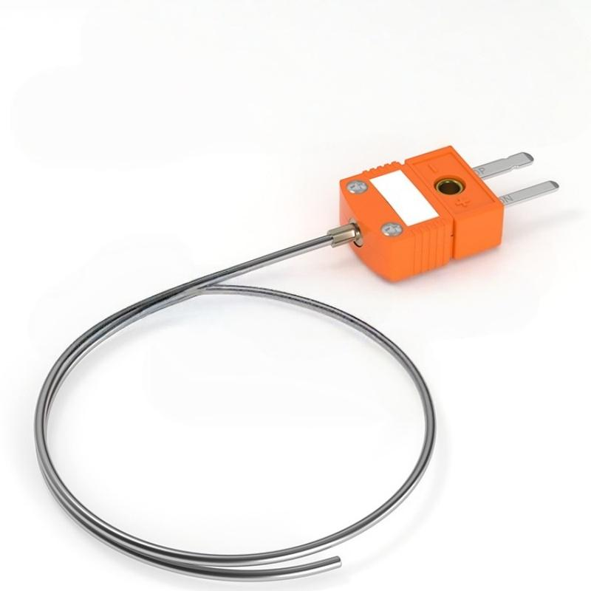
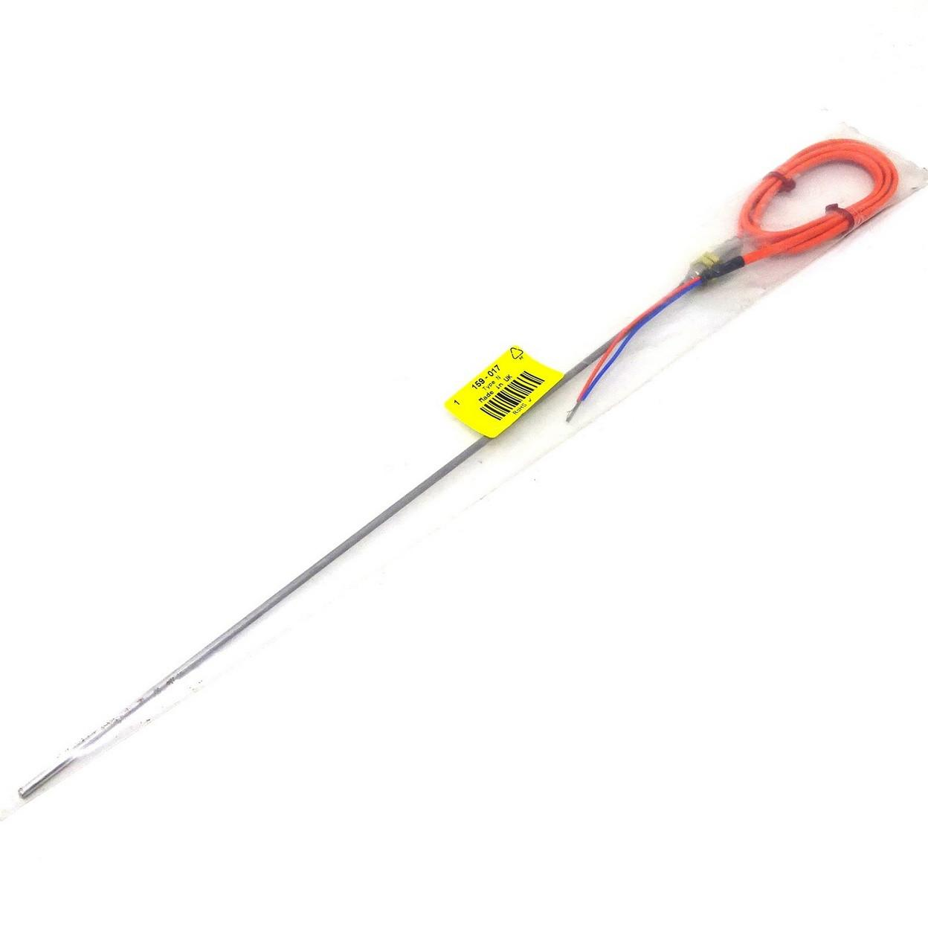
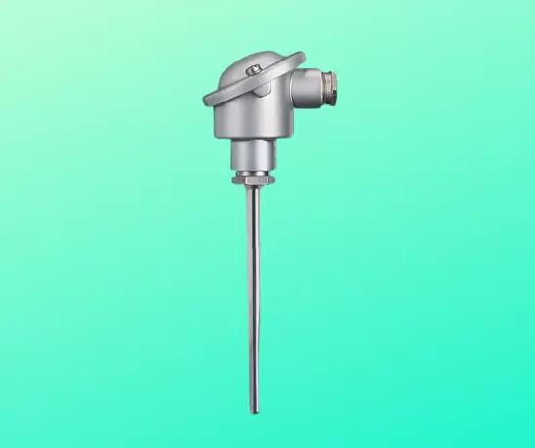
Measuring Range
Approximately:
−200°C to 1300°C
Applications
- High-temperature industrial measurements
- Power generation
- Aerospace

6. Type R Thermocouple
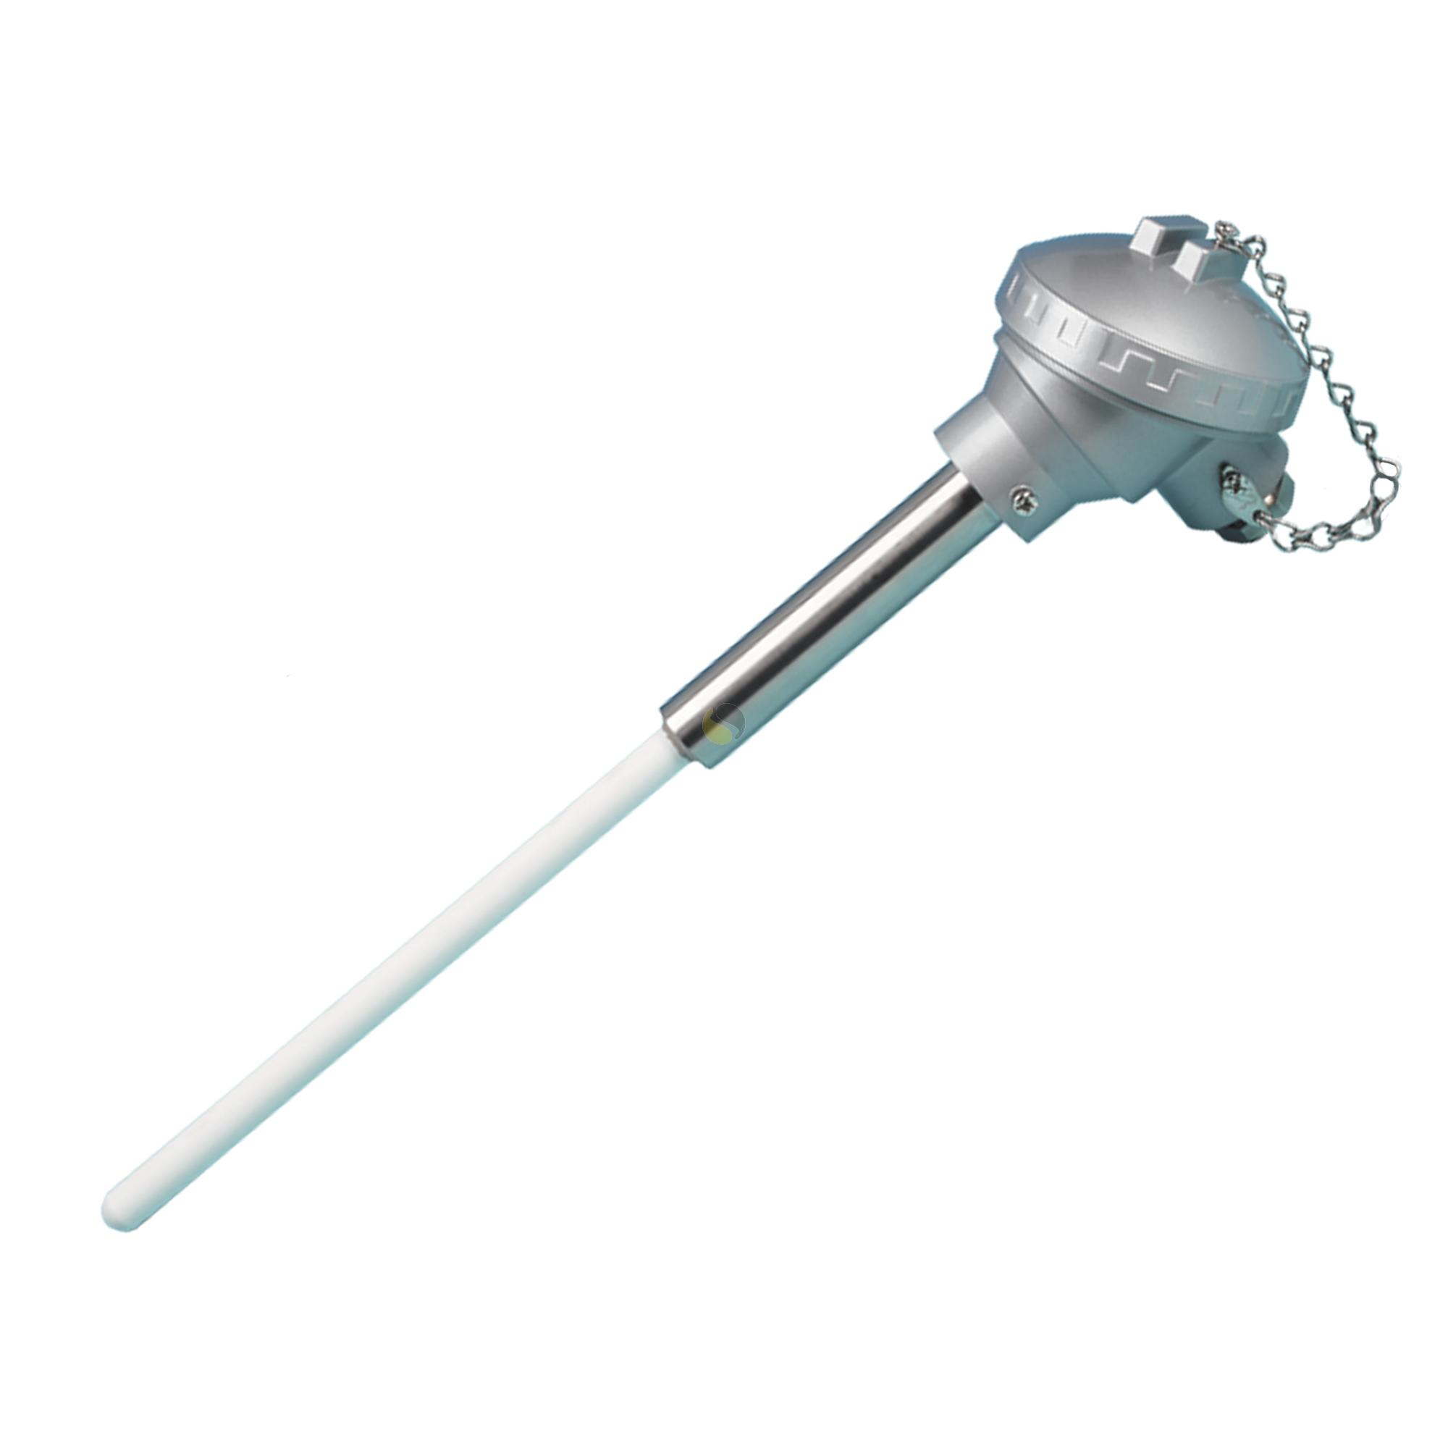
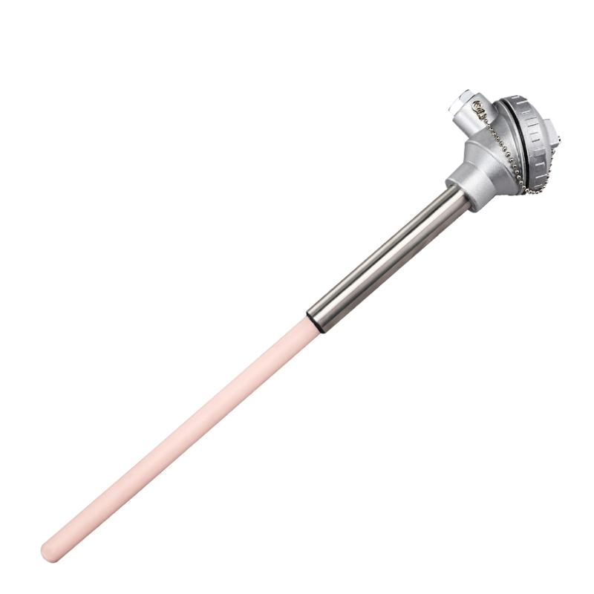
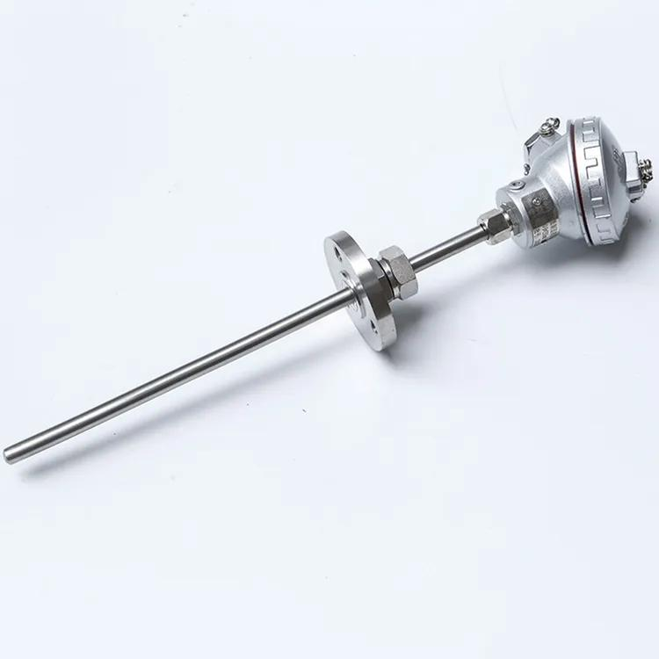
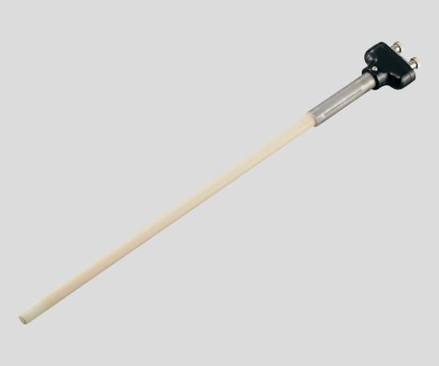
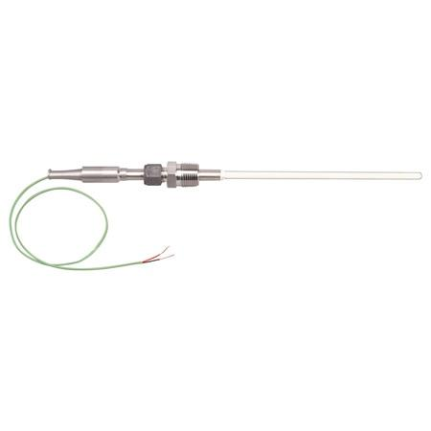
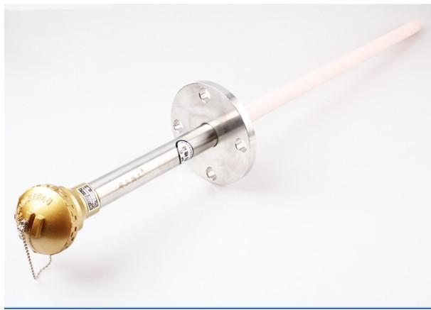
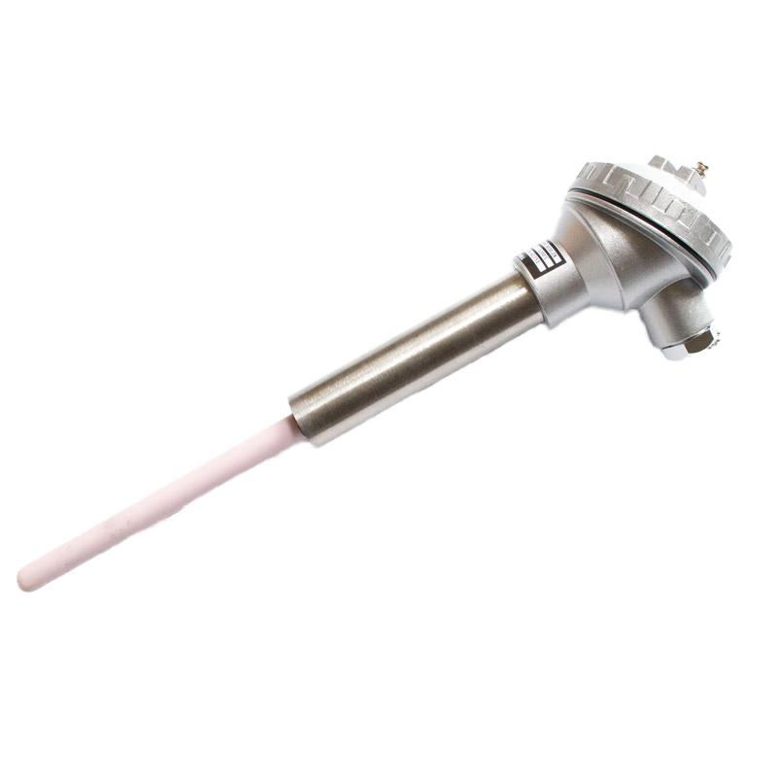
Materials
- Platinum / Platinum-Rhodium
Measuring Range
Approximately:
0°C to 1600°C
Applications
- Glass industry
- High-temperature furnaces
- Calibration laboratories

7. Type S Thermocouple
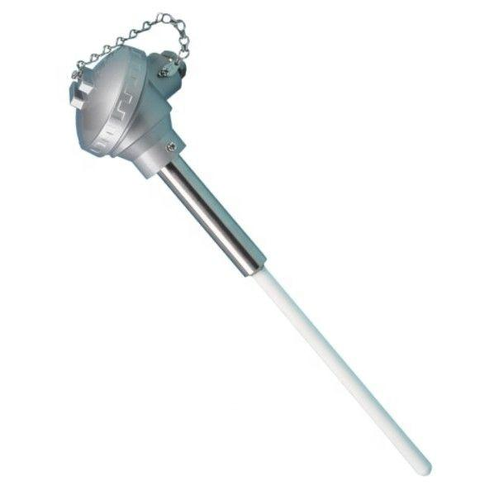
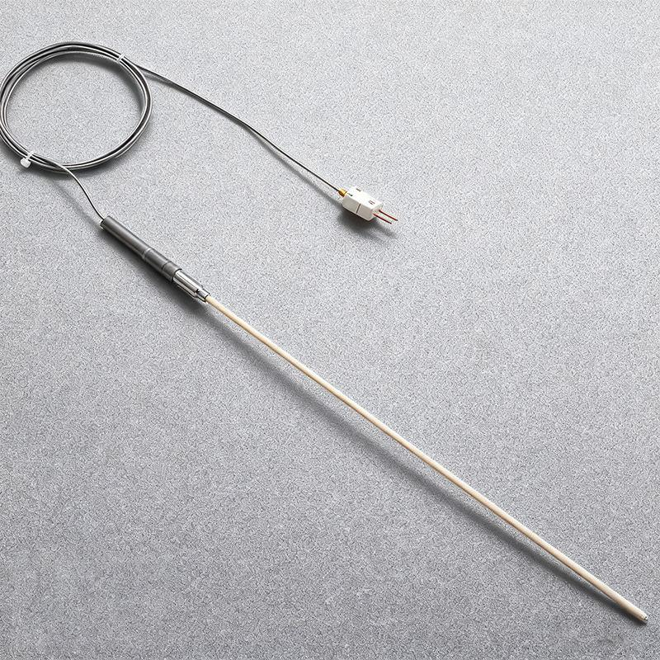
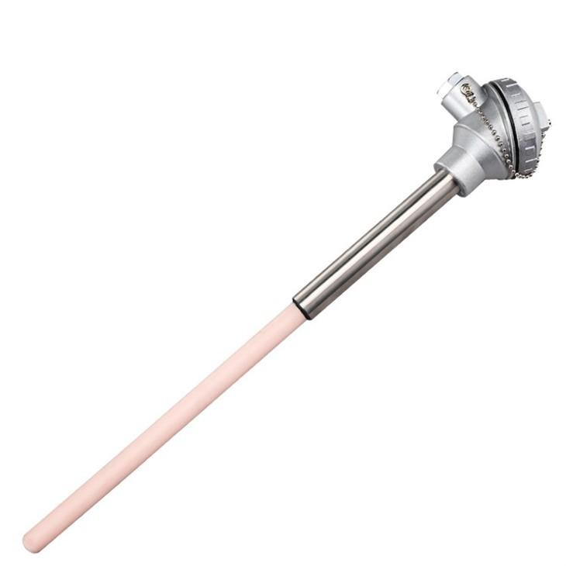
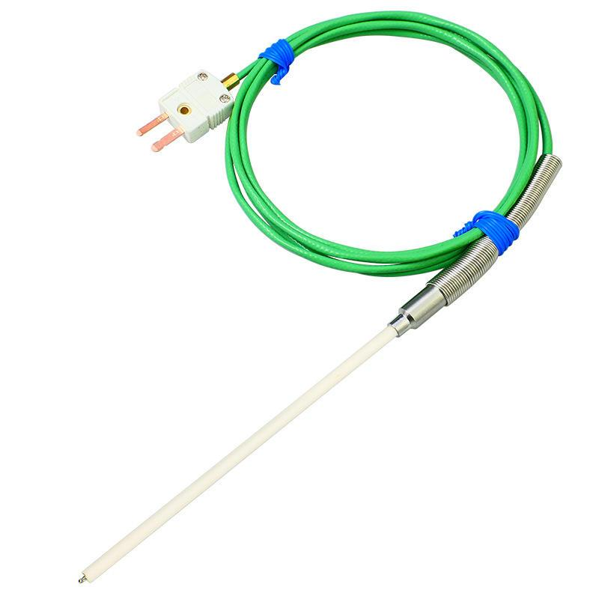
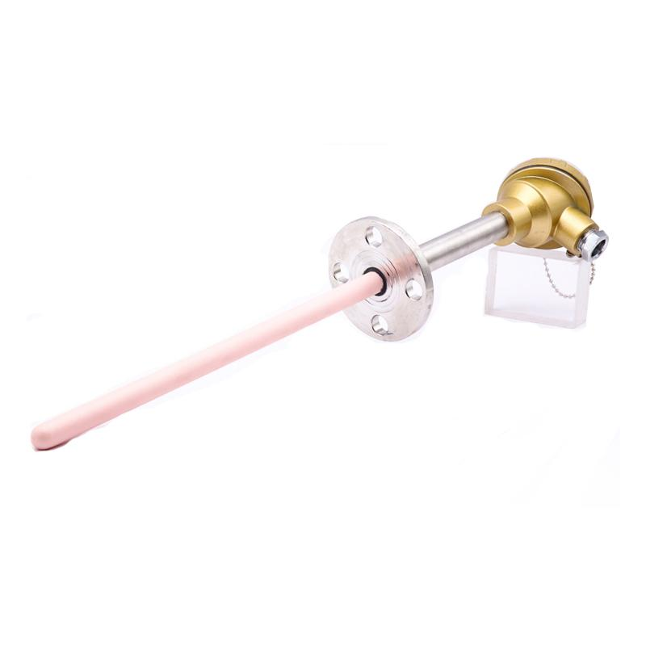
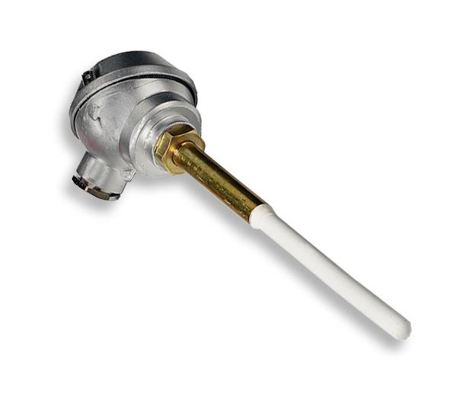
Measuring Range
Approximately:
0°C to 1600°C
Applications
- Calibration laboratories
- Industrial furnaces

8. Type B Thermocouple
# Source: AI Source: Provided by: [Data Path: Persons Table -> ID Column: 1, Name_En Column: Motasem Essam] -> From: [ChatGPT] on [7/17/2026]
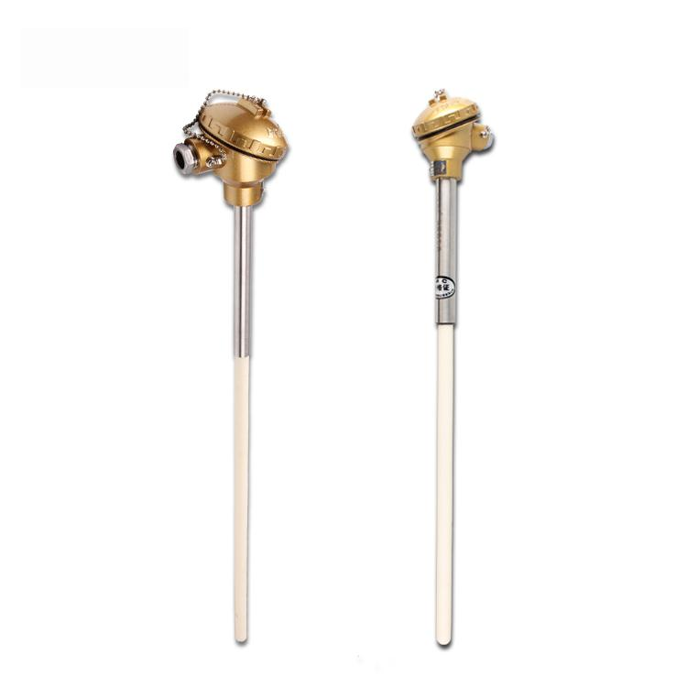
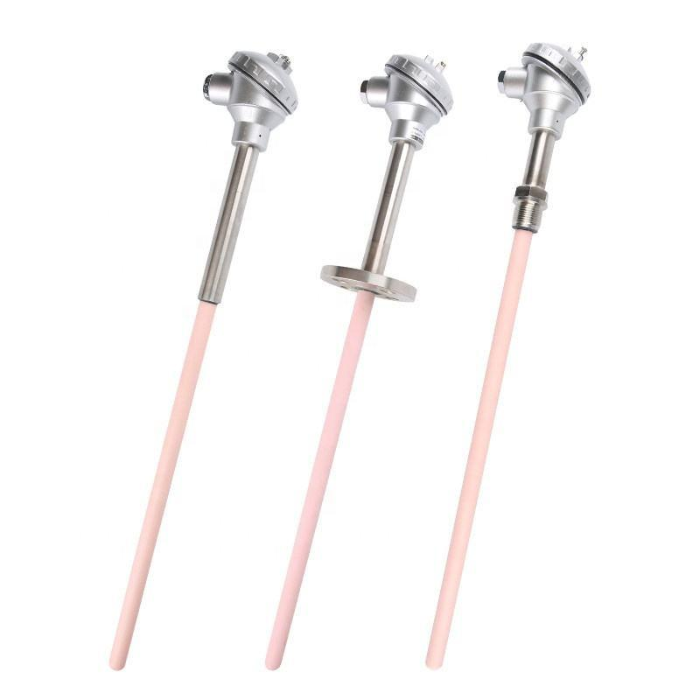
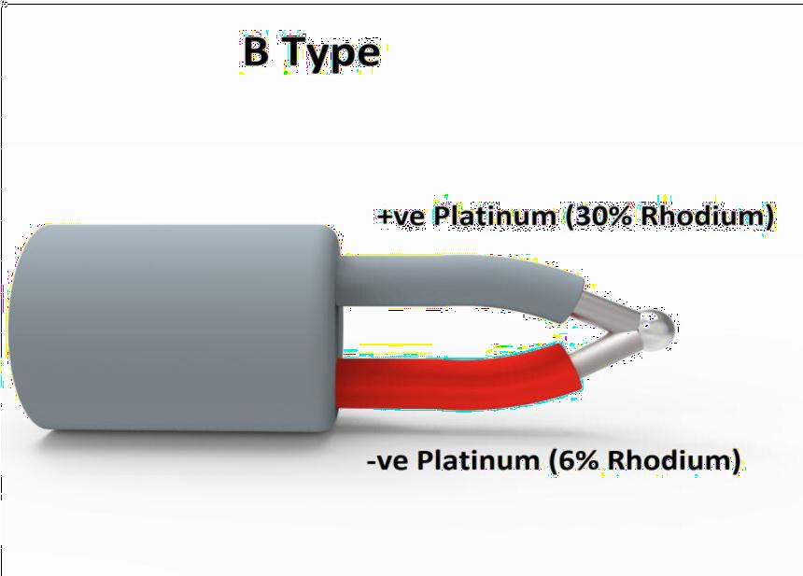
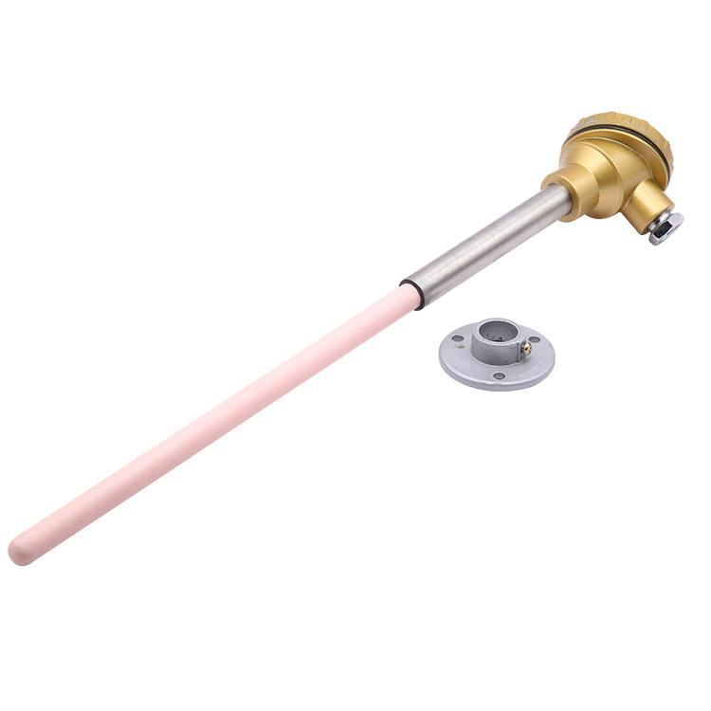
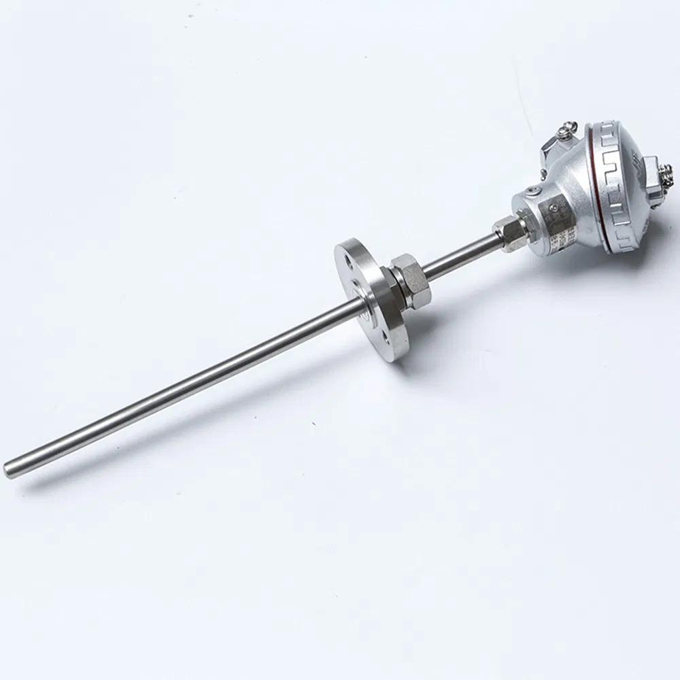
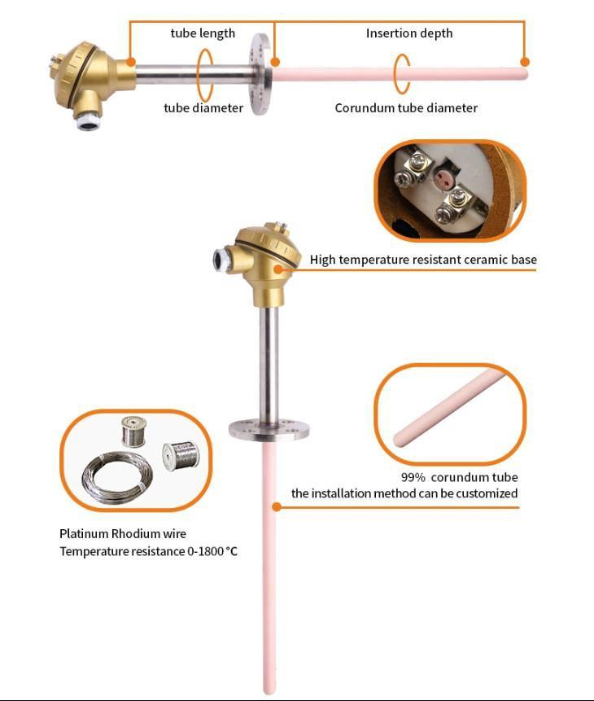
Measuring Range
Approximately:
600°C to 1800°C
Applications
- Steel industry
- Very high-temperature furnaces

Measuring Units
# Source: AI Source: Provided by: [Data Path: Persons Table -> ID Column: 1, Name_En Column: Motasem Essam] -> From: [ChatGPT] on [7/17/2026]
Thermocouples typically display:
- Degrees Celsius (°C)
- Degrees Fahrenheit (°F)
- Kelvin (K)

Measuring Range
# Source: AI Source: Provided by: [Data Path: Persons Table -> ID Column: 1, Name_En Column: Motasem Essam] -> From: [ChatGPT] on [7/17/2026]
The measuring range depends on the thermocouple type.
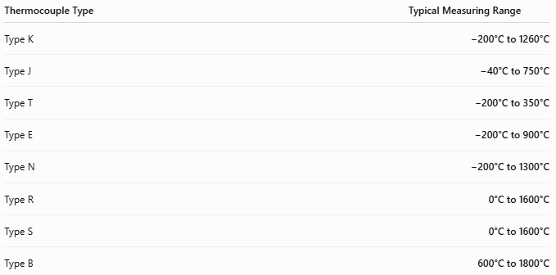
Thermocouple Type | Typical Measuring Range
Type K | −200°C to 1260°C
Type J | −40°C to 750°C
Type T | −200°C to 350°C
Type E | −200°C to 900°C
Type N | −200°C to 1300°C
Type R | 0°C to 1600°C
Type S | 0°C to 1600°C
Type B | 600°C to 1800°C

Resolution
# Source: AI Source: Provided by: [Data Path: Persons Table -> ID Column: 1, Name_En Column: Motasem Essam] -> From: [ChatGPT] on [7/17/2026]
Resolution depends primarily on the measuring instrument connected to the thermocouple.
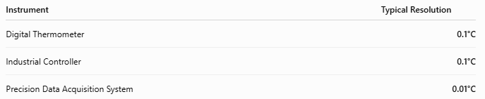
Instrument | Typical Resolution
Digital Thermometer | 0.1°C
Industrial Controller | 0.1°C
Precision Data Acquisition System | 0.01°C

Accuracy
# Source: AI Source: Provided by: [Data Path: Persons Table -> ID Column: 1, Name_En Column: Motasem Essam] -> From: [ChatGPT] on [7/17/2026]
Accuracy depends on the thermocouple type, tolerance class, and measuring instrument.
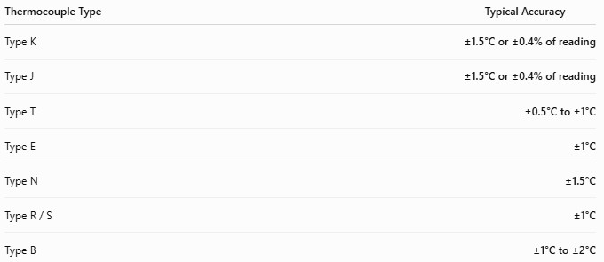
Thermocouple Type | Typical Accuracy
Type K | ±1.5°C or ±0.4% of reading
Type J | ±1.5°C or ±0.4% of reading
Type T | ±0.5°C to ±1°C
Type E | ±1°C
Type N | ±1.5°C
Type R / S | ±1°C
Type B | ±1°C to ±2°C
Notes
- Accuracy improves when higher tolerance classes and calibrated instruments are used.
- Cold-junction compensation is required for accurate measurements.
- Measurement uncertainty increases at very high temperatures.

How to Use a Thermocouple
# Source: AI Source: Provided by: [Data Path: Persons Table -> ID Column: 1, Name_En Column: Motasem Essam] -> From: [ChatGPT] on [7/17/2026]
- Connect the thermocouple to a compatible thermometer or controller.
- Place the sensing junction in contact with the object or environment.
- Wait for the reading to stabilize.
- Read the displayed temperature.

Example
# Source: AI Source: Provided by: [Data Path: Persons Table -> ID Column: 1, Name_En Column: Motasem Essam] -> From: [ChatGPT] on [7/17/2026]
Measured temperature:
785°C

Applications
# Source: AI Source: Provided by: [Data Path: Persons Table -> ID Column: 1, Name_En Column: Motasem Essam] -> From: [ChatGPT] on [7/17/2026]
Thermocouples are used in:
- Steel manufacturing
- Glass production
- Chemical processing
- Aerospace
- Automotive testing
- Power plants
- HVAC
- Food processing
- Scientific laboratories
- Kilns and furnaces

Advantages
# Source: AI Source: Provided by: [Data Path: Persons Table -> ID Column: 1, Name_En Column: Motasem Essam] -> From: [ChatGPT] on [7/17/2026]
A thermocouple:
- Measures an extremely wide temperature range.
- Responds quickly.
- Is rugged and durable.
- Is relatively inexpensive.
- Can operate in harsh environments.
- Requires no external power at the sensing junction.

Limitations
# Source: AI Source: Provided by: [Data Path: Persons Table -> ID Column: 1, Name_En Column: Motasem Essam] -> From: [ChatGPT] on [7/17/2026]
A thermocouple:
- Produces a very small voltage requiring amplification.
- Is generally less accurate than RTDs over moderate temperature ranges.
- Requires cold-junction compensation.
- Accuracy may drift over time at very high temperatures.

Sources of Error
# Source: AI Source: Provided by: [Data Path: Persons Table -> ID Column: 1, Name_En Column: Motasem Essam] -> From: [ChatGPT] on [7/17/2026]
Instrument Errors
- Poor calibration
- Cold-junction compensation error
- Electrical noise

User Errors
- Incorrect thermocouple type selection
- Improper probe placement
- Loose electrical connections

Environmental Errors
- Electromagnetic interference
- Oxidation of wires
- Thermal gradients
- Mechanical damage

Comparison with Other Temperature Measuring Instruments
# Source: AI Source: Provided by: [Data Path: Persons Table -> ID Column: 1, Name_En Column: Motasem Essam] -> From: [ChatGPT] on [7/17/2026]
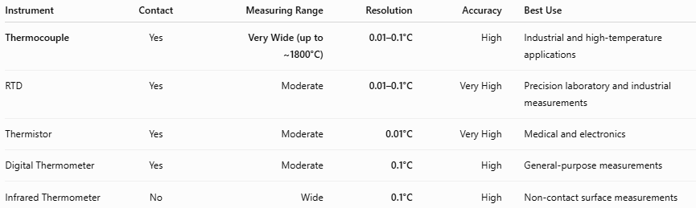
Instrument | Contact | Measuring Range | Resolution | Accuracy | Best Use
Thermocouple | Yes | Very Wide (up to ~1800°C) | 0.01–0.1°C | High | Industrial and high-temperature applications
RTD | Yes | Moderate | 0.01–0.1°C | Very High | Precision laboratory and industrial measurements
Thermistor | Yes | Moderate | 0.01°C | Very High | Medical and electronics
Digital Thermometer | Yes | Moderate | 0.1°C | High | General-purpose measurements
Infrared Thermometer | No | Wide | 0.1°C | High | Non-contact surface measurements

Care and Maintenance
# Source: AI Source: Provided by: [Data Path: Persons Table -> ID Column: 1, Name_En Column: Motasem Essam] -> From: [ChatGPT] on [7/17/2026]
To maintain accuracy:
- Protect the probe from mechanical damage.
- Avoid contamination of the sensing junction.
- Calibrate periodically.
- Use the correct extension wires.
- Replace damaged probes.

Common Mistakes
# Source: AI Source: Provided by: [Data Path: Persons Table -> ID Column: 1, Name_En Column: Motasem Essam] -> From: [ChatGPT] on [7/17/2026]
- Mixing thermocouple wire types.
- Using incorrect connectors.
- Ignoring cold-junction compensation.
- Placing the sensing junction incorrectly.
- Using a thermocouple beyond its rated temperature range.

Key Points
# Source: AI Source: Provided by: [Data Path: Persons Table -> ID Column: 1, Name_En Column: Motasem Essam] -> From: [ChatGPT] on [7/17/2026]
- A Thermocouple measures temperature using the Seebeck Effect.
- It consists of two dissimilar metal wires joined at one end.
- Common types include:
  - Type K
  - Type J
  - Type T
  - Type E
  - Type N
  - Type R
  - Type S
  - Type B
- It offers one of the widest temperature ranges of any temperature sensor.
- Thermocouples are extensively used in industrial, laboratory, aerospace, automotive, and power-generation applications.

Conclusion
# Source: AI Source: Provided by: [Data Path: Persons Table -> ID Column: 1, Name_En Column: Motasem Essam] -> From: [ChatGPT] on [7/17/2026]
A Thermocouple is one of the most versatile and widely used temperature-measuring sensors, capable of measuring temperatures from cryogenic conditions to extremely high industrial furnace temperatures. Its simple construction, durability, rapid response, and broad operating range make it indispensable in industrial automation, manufacturing, scientific research, and process control. Although it requires proper calibration and cold-junction compensation for maximum accuracy, it remains the preferred sensor for demanding temperature measurement applications.

